

Faculty of Computing

MCSD 1123 - Big Data Management

SECTION 01

Assignment 1: Report 1b

**Lecturer:**

PM DR. Mohd Shahizan Othman

Group name: TheBoys

| Name | Matric No. |
| --- | --- |
| Pang Chern Hong | MCS231006 |
| Nian Cong | MCS231007 |
| Wu JiaMing | MCS221033 |
| Liu KaiYuan | MCS231020 |

INTRODUCTION

This dataset contains 2-years sales performance data from 2020 to 2021, which includes the information of customers, products, sales personals, sales region, target sales, total sales, sales years, sales months and sales quarters. Objective of our case study is to process the data and visualise it through the dashboard in order to do some analysis based on that.

Data Processing

We built some pivot tables which get the data from the dataset 2, then use it to process the data into the table that contains the desired information that is grouped by different elements to ease our work.

Disussion

On this sales data table, we wish to determine whether the target of sales has been achieved, to identify the best salesperson, and the best seller. We first extracted the data items related to our concerns and made a pivot table on a new page to include the data we want and group them into different categories in order to identify them based on the months, years, people, or find out the total amount of sales over a certain period. For example, to generate a "Monthly Sales" table, we may need the information about the amount of sales and sales targets for each month. Then, we take "sum of target" and "sum of sales" as values, after that we distribute them into monthly totals(As shown in Figure 1).

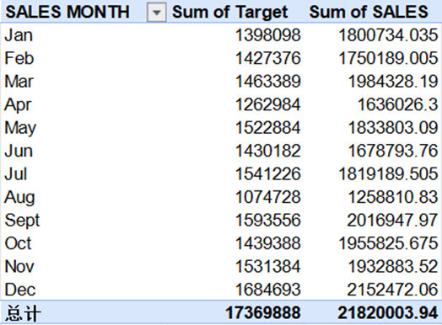

Figure 1: Monthly sales and sales target.

In order to ease the filtering process and to flexibly present the dashboard, we introduced slicing filters(As shown in Figure 2). Next, we use the filter connection function to link the filter items with each other, so that by changing one of the filters then another filter and the pivot table can be affected as well, making the dashboard interactable(As shown in Figure 3).

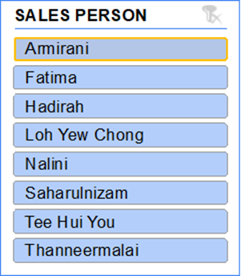

Figure 2: Slicing filters of sales person.

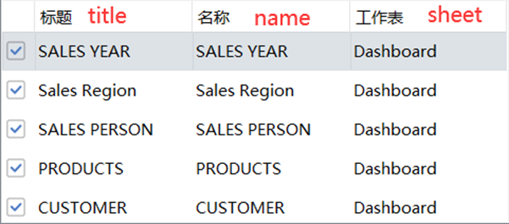

Figure 3: filter connection.

Furthermore, we use tools to make the pivot table into some appropriate pivot chart that can indicate the pattern we want to show, visualise the data graphically, so that we can have a rough idea from these complex data and can manage to describe it. As shown in Figure 4,We can see that every month in 2020 exceeded the predetermined sales target. By clicking at the 2020 in the filter of sales year, we can observe in the graph that This year’s sales champion is Loh Yew chong followed by Saharulnizam, Hadirah, Naini and the others. All 5 graphs will indicate different patterns and data when we select one of the options from these filters, so that we can easily see the pattern and the type of the data we want.

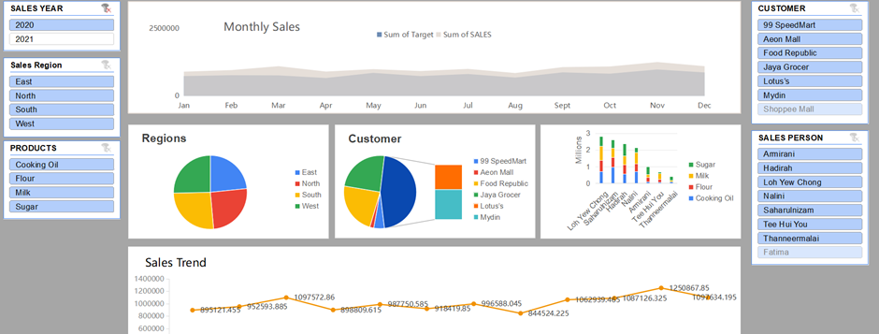

Figure 4: 2020 sales year dashboard.

If we now try to click on the filter in the sales person menu, by selecting Loh yew chong as the salesperson, all charts will display information about Loh Yew chong accordingly(refer Figure 5).We can observe that his main activities are in the Eastern region, and his main source of customers are from Food Republic and Shoppee Mall.

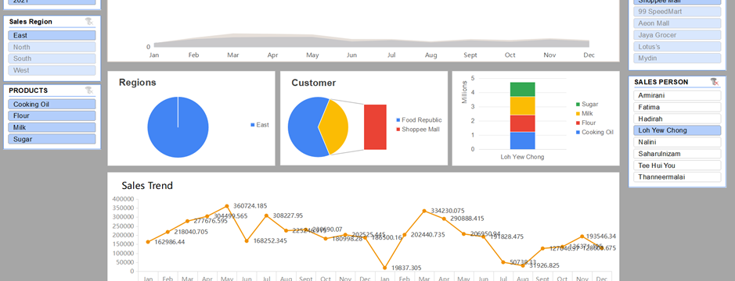

Figure 5: Dashboard of Loh Yew Chong’s data by using filter

Now we try to manipulate the filter on the product, one of the examples is that if we select cooking oil as a product and the sales year as 2021,the display of the dashboard will be shown in figure 6.

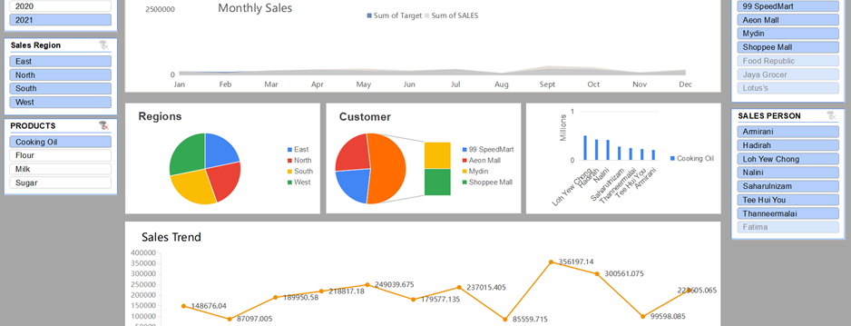

Figure 6: Select only the cooking oil related data by using filter.

Conclusion

To encapsulate, Throughout this case study, by using the data visualisation through pivot table and filter. Through these features we implemented into this dataset, we can say that the dashboard become interactive and we can easily observe and analysis data from different perspectives. In this case study, we can identify which salesperson is the best and find out their strengths and weaknesses such as their main region of business, their best seller, their customer and so on. Besides that, we also can identify the general trend of the sales and the conditions of the business environment by looking at the graphs shown in the dashboard, as an example, in this case it is clear to see that sales in 2021 were overall dropped compared to the same period in 2020.